To broadly screen the genes regulated by DACH1 through direct DNA binding within the promoter region, we searched for the previously mentioned DACH1 DNA recognition sequence with the 2000 bp upstream of every human gene [1]. A linear sequence search revealed 10 exact matches (Table 1) and 234 single mismatches (Supplemental material 1). A position-specific weight matrix was created from the conservation of each nucleotide in all positions of the sequences with 2 or less mismatches. The p-values for each binding site were estimated by comparing the match specific score with a Null-Distribution estimated by scanning intronic regions. A visual representation of these sequences was then created using the sequence logo technique [2] as shown in Figure 1. This shows that position 5, 8 and 9 have poor conservation across the retrieved sequences.

Table 2 shows the statistically over-enriched (hypergeometric test p<0.01) functional pathways from the Kyoto Encyclopedia of Genes and Genomes (KEGG) pathways [3] from the 244 matched genes. This list includes metabolism, signaling and disease related pathways. The DNA binding sequence is found in the promoter regions of enzymes utilized in the metabolic synthesis of Purine and Pyrimidine. The sequence is also found in the promoter region of genes involved in toll-like receptor pathway and glioma progression Figure 3. This could imply new avenues of research for the clinical relevance of DACH1.

Table 1: A table of the genes which have the template DNA sequence within 2000 bp upstream of their translation start site.
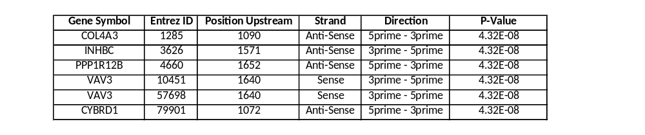

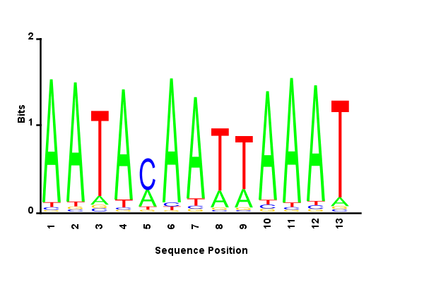
Figure 1: A sequence logo depicting the sequence conservation of the template sequence for all double mis-match hits.

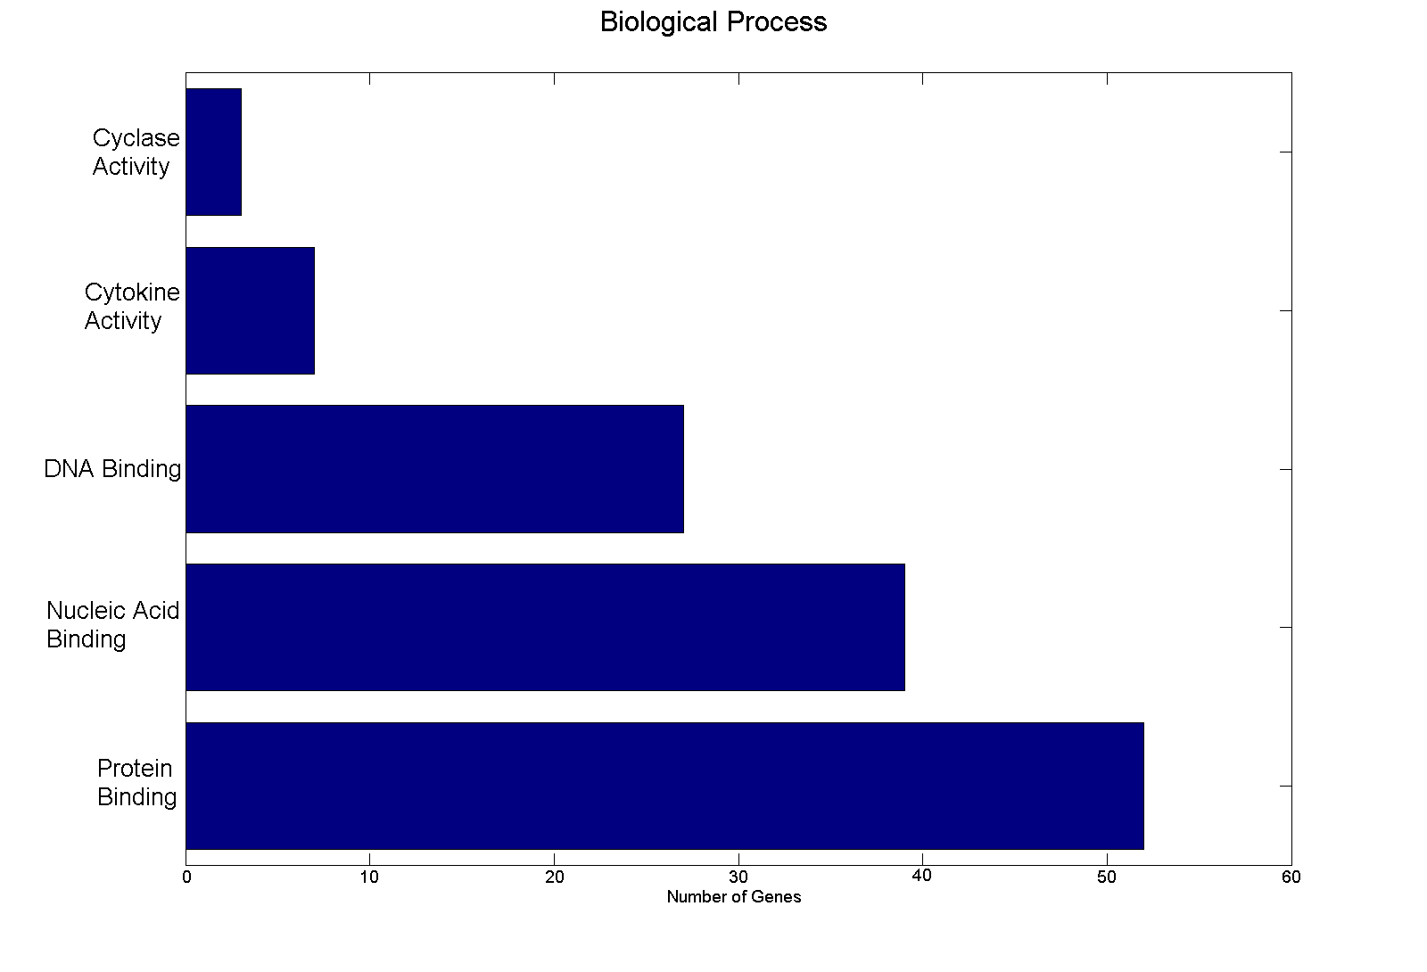
Figure 2: The Gene Ontology Biological Process categories which are over-enriched (p<0.05) in the Single-Mismatch Gene List.

Table 2: The KEGG pathways which show statistical over-representation (Hypergeometric Test p<0.01) from the list of 244 matched genes.
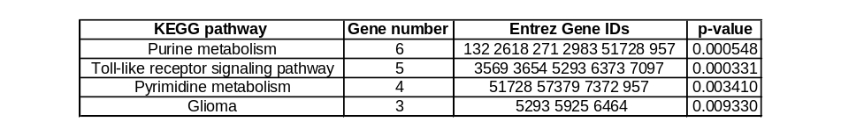

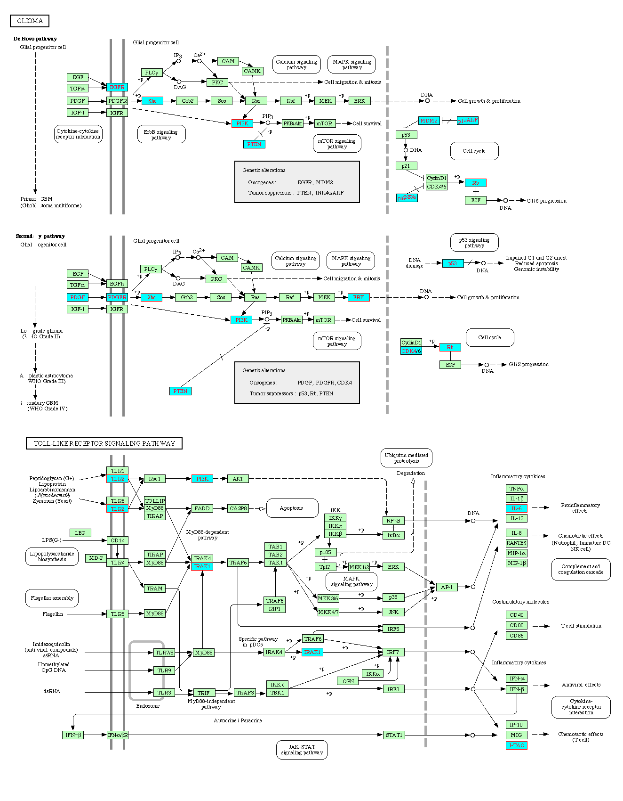
Figure 3: The Glioma and Toll-Like Receptor Signaling Pathways from KEGG [3]. The genes colored in blue have the DACH1 DNA binding sequence (with one mis-match) in their promoter sequences.

References:
[1] International Human Genome Sequencing Consortium, Finishing the euchromatic sequence of the human genome., Nature, 2004 Oct 21;431(7011):931-45
[2] TD Schneider, RM Stephens. Sequence logos: a new way to display consensus sequences. Nucleic Acids Res, 1990
[3] Kanehisa, M., Goto, S., Kawashima, S., Okuno, Y., and Hattori, M.; The KEGG resources for deciphering the genome. Nucleic Acids Res. 32, D277-D280 (2004).

